File Organization
- The File is a collection of records. Using the primary key, we can access the records. The type and frequency of access can be determined by the type of file organization which was used for a given set of records.
- File organization is a logical relationship among various records. This method defines how file records are mapped onto disk blocks.
- File organization is used to describe the way in which the records are stored in terms of blocks, and the blocks are placed on the storage medium.
- The first approach to map the database to the file is to use the several files and store only one fixed length record in any given file. An alternative approach is to structure our files so that we can contain multiple lengths for records.
- Files of fixed length records are easier to implement than the files of variable length records.

Objective of file organization
- It contains an optimal selection of records, i.e., records can be selected as fast as possible.
- To perform insert, delete or update transaction on the records should be quick and easy.
- The duplicate records cannot be induced as a result of insert, update or delete.
- For the minimal cost of storage, records should be stored efficiently.

Types of file organization:
File organization contains various methods. These particular methods have pros and cons on the basis of access or selection. In the file organization, the programmer decides the best-suited file organization method according to his requirement.
Types of file organization are as follows:
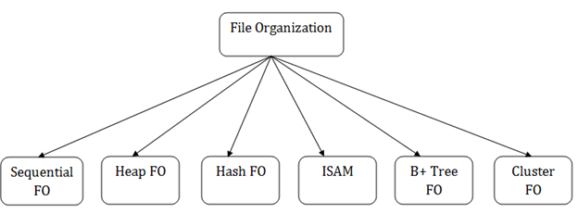
- Sequential file organization
- Heap file organization
- Hash file organization
- B+ file organization
- Indexed sequential access method (ISAM)
- Cluster file organization

Sequential File Organization
This method is the easiest method for file organization. In this method, files are stored sequentially. This method can be implemented in two ways:

1. Pile File Method:
- It is a quite simple method. In this method, we store the record in a sequence, i.e., one after another. Here, the record will be inserted in the order in which they are inserted into tables.
- In case of updating or deleting of any record, the record will be searched in the memory blocks. When it is found, then it will be marked for deleting, and the new record is inserted.
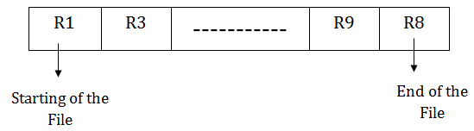

Insertion of the new record:
Suppose we have four records R1, R3 and so on upto R9 and R8 in a sequence. Hence, records are nothing but a row in the table. Suppose we want to insert a new record R2 in the sequence, then it will be placed at the end of the file. Here, records are nothing but a row in any table.
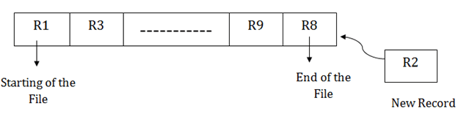

2. Sorted File Method:
- In this method, the new record is always inserted at the file's end, and then it will sort the sequence in ascending or descending order. Sorting of records is based on any primary key or any other key.
- In the case of modification of any record, it will update the record and then sort the file, and lastly, the updated record is placed in the right place.

Insertion of the new record:
Suppose there is a pre-existing sorted sequence of four records R1, R3 and so on upto R6 and R7. Suppose a new record R2 has to be inserted in the sequence, then it will be inserted at the end of the file, and then it will sort the sequence.
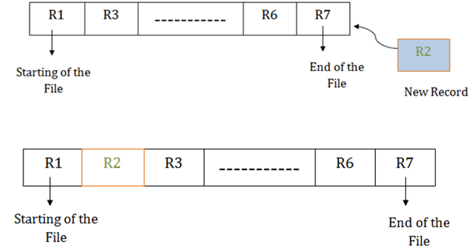

Pros of sequential file organization
- It contains a fast and efficient method for the huge amount of data.
- In this method, files can be easily stored in cheaper storage mechanism like magnetic tapes.
- It is simple in design. It requires no much effort to store the data.
- This method is used when most of the records have to be accessed like grade calculation of a student, generating the salary slip, etc.
- This method is used for report generation or statistical calculations.

Cons of sequential file organization
- It will waste time as we cannot jump on a particular record that is required but we have to move sequentially which takes our time.
- Sorted file method takes more time and space for sorting the records.

B+ File Organization
- B+ tree file organization is the advanced method of an indexed sequential access method. It uses a tree-like structure to store records in File.
- It uses the same concept of key-index where the primary key is used to sort the records. For each primary key, the value of the index is generated and mapped with the record.
- The B+ tree is similar to a binary search tree (BST), but it can have more than two children. In this method, all the records are stored only at the leaf node. Intermediate nodes act as a pointer to the leaf nodes. They do not contain any records.
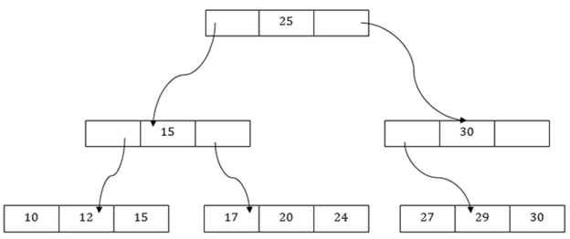

The above B+ tree shows that:
- There is one root node of the tree, i.e., 25.
- There is an intermediary layer with nodes. They do not store the actual record. They have only pointers to the leaf node.
- The nodes to the left of the root node contain the prior value of the root and nodes to the right contain next value of the root, i.e., 15 and 30 respectively.
- There is only one leaf node which has only values, i.e., 10, 12, 17, 20, 24, 27 and 29.
- Searching for any record is easier as all the leaf nodes are balanced.
- In this method, searching any record can be traversed through the single path and accessed easily.

Pros of B+ tree file organization
- In this method, searching becomes very easy as all the records are stored only in the leaf nodes and sorted the sequential linked list.
- Traversing through the tree structure is easier and faster.
- The size of the B+ tree has no restrictions, so the number of records can increase or decrease and the B+ tree structure can also grow or shrink.
- It is a balanced tree structure, and any insert/update/delete does not affect the performance of tree.

Cons of B+ tree file organization
- This method is inefficient for the static method

Indexing in DBMS
- Indexing is used to optimize the performance of a database by minimizing the number of disk accesses required when a query is processed.
- The index is a type of data structure. It is used to locate and access the data in a database table quickly.

Index structure:
Indexes can be created using some database columns.
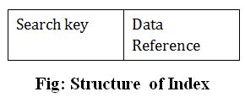
- The first column of the database is the search key that contains a copy of the primary key or candidate key of the table. The values of the primary key are stored in sorted order so that the corresponding data can be accessed easily.
- The second column of the database is the data reference. It contains a set of pointers holding the address of the disk block where the value of the particular key can be found.

Indexing Methods
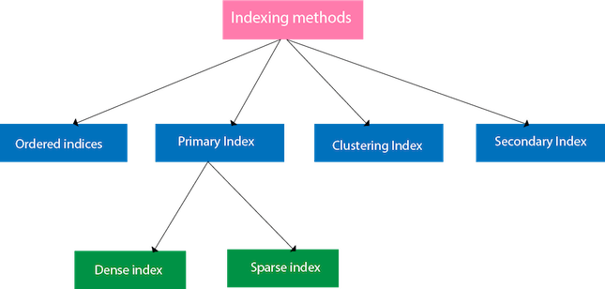

Ordered indices
The indices are usually sorted to make searching faster. The indices which are sorted are known as ordered indices.
Example: Suppose we have an employee table with thousands of record and each of which is 10 bytes long. If their IDs start with 1, 2, 3....and so on and we have to search student with ID-543.
- In the case of a database with no index, we have to search the disk block from starting till it reaches 543. The DBMS will read the record after reading 543*10=5430 bytes.
- In the case of an index, we will search using indexes and the DBMS will read the record after reading 542*2= 1084 bytes which are very less compared to the previous case.

Primary Index
- If the index is created on the basis of the primary key of the table, then it is known as primary indexing. These primary keys are unique to each record and contain 1:1 relation between the records.
- As primary keys are stored in sorted order, the performance of the searching operation is quite efficient.
- The primary index can be classified into two types: Dense index and Sparse index.

Dense index
- The dense index contains an index record for every search key value in the data file. It makes searching faster.
- In this, the number of records in the index table is same as the number of records in the main table.
- It needs more space to store index record itself. The index records have the search key and a pointer to the actual record on the disk.
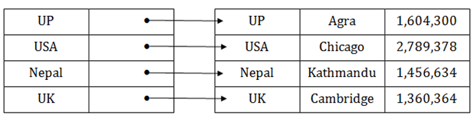

Sparse index
- In the data file, index record appears only for a few items. Each item points to a block.
- In this, instead of pointing to each record in the main table, the index points to the records in the main table in a gap.
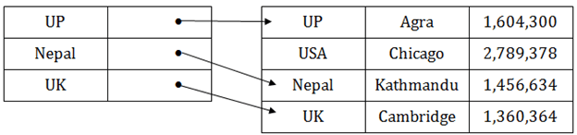

Clustering Index
- A clustered index can be defined as an ordered data file. Sometimes the index is created on non-primary key columns which may not be unique for each record.
- In this case, to identify the record faster, we will group two or more columns to get the unique value and create index out of them. This method is called a clustering index.
- The records which have similar characteristics are grouped, and indexes are created for these group.
Example: suppose a company contains several employees in each department. Suppose we use a clustering index, where all employees which belong to the same Dept_ID are considered within a single cluster, and index pointers point to the cluster as a whole. Here Dept_Id is a non-unique key.
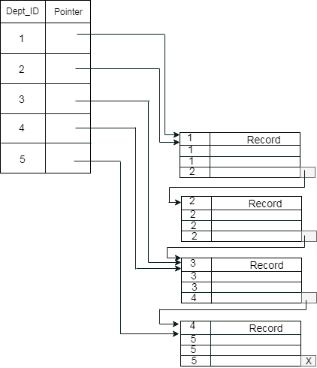
The previous schema is little confusing because one disk block is shared by records which belong to the different cluster. If we use separate disk block for separate clusters, then it is called better technique.
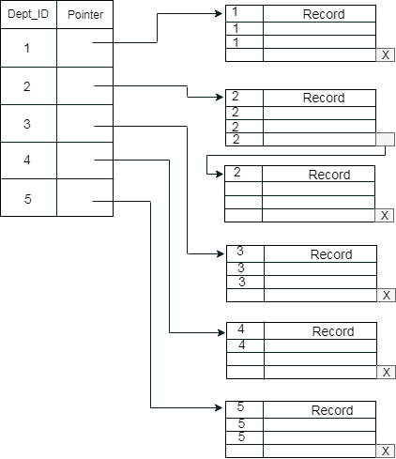

Secondary Index
In the sparse indexing, as the size of the table grows, the size of mapping also grows. These mappings are usually kept in the primary memory so that address fetch should be faster. Then the secondary memory searches the actual data based on the address got from mapping. If the mapping size grows, then fetching the address itself becomes slower. In this case, the sparse index will not be efficient. To overcome this problem, secondary indexing is introduced.
In secondary indexing, to reduce the size of mapping, another level of indexing is introduced. In this method, the huge range for the columns is selected initially so that the mapping size of the first level becomes small. Then each range is further divided into smaller ranges. The mapping of the first level is stored in the primary memory, so that address fetch is faster. The mapping of the second level and actual data are stored in the secondary memory (hard disk).
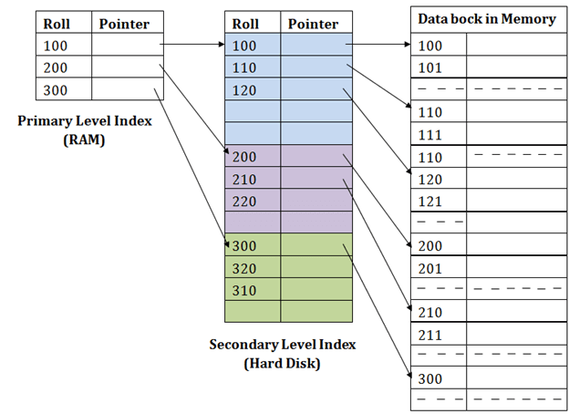
For example:
- If you want to find the record of roll 111 in the diagram, then it will search the highest entry which is smaller than or equal to 111 in the first level index. It will get 100 at this level.
- Then in the second index level, again it does max (111) <= 111 and gets 110. Now using the address 110, it goes to the data block and starts searching each record till it gets 111.
- This is how a search is performed in this method. Inserting, updating or deleting is also done in the same manner.

B+ Tree
- The B+ tree is a balanced binary search tree. It follows a multi-level index format.
- In the B+ tree, leaf nodes denote actual data pointers. B+ tree ensures that all leaf nodes remain at the same height.
- In the B+ tree, the leaf nodes are linked using a link list. Therefore, a B+ tree can support random access as well as sequential access.

Structure of B+ Tree
- In the B+ tree, every leaf node is at equal distance from the root node. The B+ tree is of the order n where n is fixed for every B+ tree.
- It contains an internal node and leaf node.
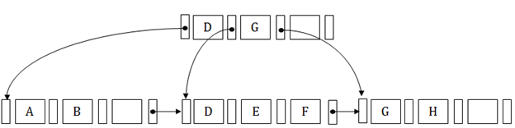

Internal node
- An internal node of the B+ tree can contain at least n/2 record pointers except the root node.
- At most, an internal node of the tree contains n pointers.

Leaf node
- The leaf node of the B+ tree can contain at least n/2 record pointers and n/2 key values.
- At most, a leaf node contains n record pointer and n key values.
- Every leaf node of the B+ tree contains one block pointer P to point to next leaf node.

Searching a record in B+ Tree
Suppose we have to search 55 in the below B+ tree structure. First, we will fetch for the intermediary node which will direct to the leaf node that can contain a record for 55.
So, in the intermediary node, we will find a branch between 50 and 75 nodes. Then at the end, we will be redirected to the third leaf node. Here DBMS will perform a sequential search to find 55.
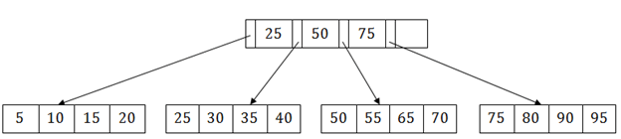

B+ Tree Insertion
Suppose we want to insert a record 60 in the below structure. It will go to the 3rd leaf node after 55. It is a balanced tree, and a leaf node of this tree is already full, so we cannot insert 60 there.
In this case, we have to split the leaf node, so that it can be inserted into tree without affecting the fill factor, balance and order.
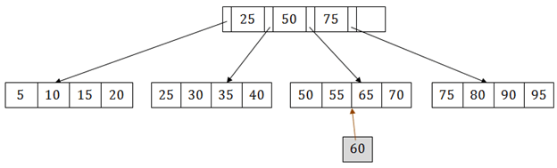
The 3rd leaf node has the values (50, 55, 60, 65, 70) and its current root node is 50. We will split the leaf node of the tree in the middle so that its balance is not altered. So we can group (50, 55) and (60, 65, 70) into 2 leaf nodes.
If these two has to be leaf nodes, the intermediate node cannot branch from 50. It should have 60 added to it, and then we can have pointers to a new leaf node.
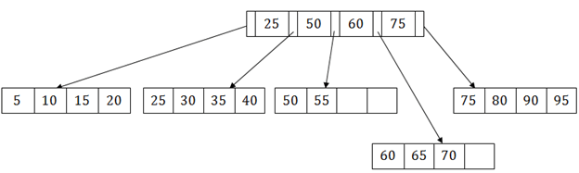
This is how we can insert an entry when there is overflow. In a normal scenario, it is very easy to find the node where it fits and then place it in that leaf node.

B+ Tree Deletion
Suppose we want to delete 60 from the above example. In this case, we have to remove 60 from the intermediate node as well as from the 4th leaf node too. If we remove it from the intermediate node, then the tree will not satisfy the rule of the B+ tree. So we need to modify it to have a balanced tree.
After deleting node 60 from above B+ tree and re-arranging the nodes, it will show as follows:
